Worksheet circular motion solutions

1. If an object traveling in circular motion experiences a centripetal force of zero Newtons, what happens to the object's trajectory?
The object will travel tangentially to its previous circular path.
2. A 3kg object traveling in uniform circular motion feels a net centripetal force of 5.2N. The circumference of the circle the object is traversing is 0.2m. What is the objects tangential velocity?
$$F_{c}=\frac{mv^{2}}{r}=\frac{2πmv^{2}}{c}→v=\sqrt{\frac{cF_{c}}{2πm}}=\sqrt{\frac{(0.2m)\left(5.2N\right)}{2\left(3.14\right)\left(3kg\right)}}=0.23\frac{m}{s}$$
3. When the roller coaster shown in the picture below is going through a loop on the inner perimeter what would the equation for the sum of the radial forces look like if the coaster were at location 1, 2, and 3? Write your equations only in terms of the various forces with the appropriate subscripts.
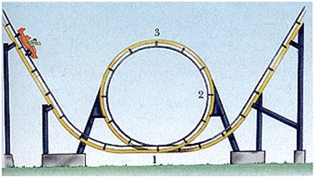

$${∑F}_{r1}= F_{c}=ma_{c}=F_{N}-F_{g}$$

$${∑F}_{r2}= F_{c}=ma_{c}=F_{N}$$

$${∑F}_{r3}= F_{c}=ma_{c}=F_{N}+F_{g}$$

Where F_{r} is the radial forces, F_{c} is the centripetal force, F_{N} is the normal force, and F_{g} is the gravitational force.

