Worksheet - Fluids in motion
1. The water flowing through pipe A flows out through pipes B, C, and D. The diameter of a cross section of pipe A is 2cm, and all of other pipes have a diameter of 1.4cm. The volume flow rate in pipes B, C, and D are 28L/min, 18L/min, and 10L/min respectively.
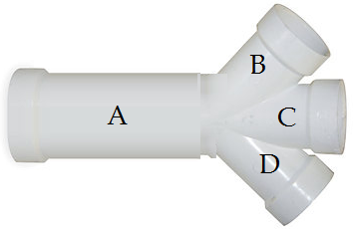
a) What is the volume flow rate of pipe A?
b) What is the pipe A to pipe B ratio of the speed of water?

2. A liquid of density 820 kg/m³ flows through a horizontal pipe that has a cross sectional area of 2.8x10⁻² m² in region A and a cross sectional area of 8.1x10⁻² m² in region B. The pressure difference between the two regions is 6.1x10³ Pa.
a) What is the volume flow rate?
b) What is the mass flow rate?

