Worksheet forces and friction solutions
I. Solve each equation for B algebraically.
1. $R=3KB$ 2. $F\frac{K}{B}=2W$ 3. $ZK^{2}=R+B$ 4. $\frac{K}{Q}+L=3{(BX)}^{4}$ 5. $\frac{B}{K}-D=H$
$1.B=\frac{R}{3K}$ $2.B=\frac{FK}{2W}$ $3.B=zK^{2}-R$ $4.B=\frac{\sqrt[4]{\frac{K+QL}{3Q}}}{X}$ $5.B=K\left(H+D\right)$
II. Solve each equation trigonometrically for the component vector in terms of the angle and vector.
1.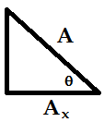 2.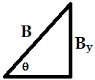 3.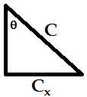 4.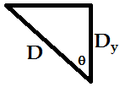
$1.A_{x}=A\cos{θ}$ $2.B_{y}=B\sin{θ}$ $3.C_{x}=C\sin{θ}$ 4. $D_{y}=D\cos{θ}$
III. Draw a free body diagram for the forces acting on the piano for each of these situations.
1. 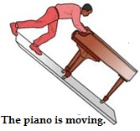 2.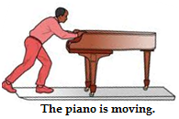 3.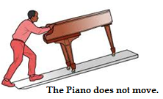
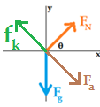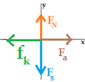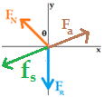
IV. Write a mathematical equation for the sum of the forces in x and y directions for each of these free-body diagrams in terms of the declared variables.
1.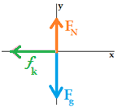2.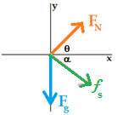3.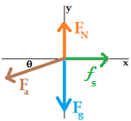4.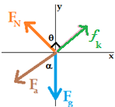

$1. ΣF_{x}=ma_{x}=-f_{k}$ $2. ΣF_{x}=ma_{x}=F_{N}\cos{θ+f_{s}\cos{α}}$
$ΣF_{y}=ma_{y}=F_{N}-F_{g}$ $ΣF_{y}=ma_{y}=F_{N}\sin{θ}-f_{s}\sin{α}-F_{g}$

$3. {ΣF_{x}=ma_{x}=f}_{s}-F_{a}\cos{θ}$ $4. ΣF_{x}=ma_{x}=f_{k}\cos{θ}-F_{N}\sin{θ-F_{a}\sin{α}}$
$ΣF_{y}=ma_{y}=F_{N}-F_{a}\sin{θ}-F_{g}$ $ΣF_{y}=ma_{y}=F_{N}\cos{θ}+f_{k}\sin{θ}-F_{a}\cos{α}-F_{g}$

Note: In situation 4., the angle between the positive x axis and the kinetic friction is equal to θ, which is what I used. You could have however used the angle between the positive y axis and the kinetic friction which is equal to 90 - θ.

