Worksheet momentum solutions

1. A car with a mass of 1Mg is at rest at a stoplight. When the light turns green, the car's engine applies a force resulting in a net force of 2kN acting on the car to the east for 10s.
a) Calculate the acceleration that the car experiences.
$$F=ma→a=\frac{F}{m}=\frac{2kN}{1Mg}=\frac{2x{10}^{3}N}{1x{10}^{3}kg}=2\frac{m}{s^{2}}$$
b) Calculate the impulse on the car.
$$J=F∆t=\left(2x{10}^{3}N\right)\left(10s\right)=2x{10}^{4}Ns$$
c) Calculate the final velocity of the car at the end of the 10 seconds.
$$v=at+v_{o}=\left(2\frac{m}{s^{2}}\right)\left(10s\right)+\left(0\frac{m}{s}\right)=20\frac{m}{s}$$
d) Calculate the initial momentum of the car.
$$p_{o}=mv_{o}=\left(1x{10}^{3}kg\right)\left(0\frac{m}{s}\right)=0\frac{kgm}{s}$$
e) Calculate the final momentum of the car.
$$p=mv=\left(1x{10}^{3}kg\right)\left(20\frac{m}{s}\right)=2x{10}^{4}\frac{kgm}{s}$$
f) Calculate the change in momentum and compare this value to the value you got in part b).
$$∆p=p-p_{o}=2x{10}^{4}\frac{kgm}{s}-0\frac{kgm}{s}=2x{10}^{4}\frac{kgm}{s}$$
Notice that the change in momentum is equal to the impulse. This is always the case.
Also notice that the units $Ns=\frac{kgm}{s}$.
2. Football player A is running due east when he jumps into the air at a 13º angle slamming into football player B's head with his lower torso. Football player B was running due west. After the collision, football player B comes to a halt while player A flies north west at a 30º angle from the horizontal.
a) Draw this situation. Label the angles and the momentum vectors.
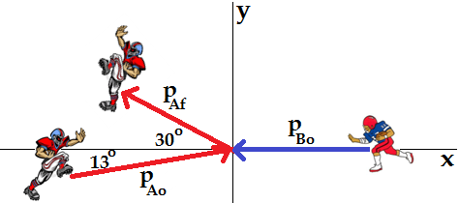
b) Is this collision elastic or inelastic, and how do you know?
This is an elastic collision due to the football players bouncing off each other.
c) Describe this situation algebraically using these two equations: ∑p_{ox} = ∑p_{fx} ∑p_{oy} = ∑p_{fy}
$∑p_{ox}=∑p_{fx}→$ $p_{Aox}-p_{Bo}={- p}_{Afx}→{m_{A}v}_{Ao}\cos\left(13^{o}\right)-{m_{B}v}_{Bo}={- m_{A}v}_{Af}\cos\left(30^{o}\right)$
$$∑p_{oy}=∑p_{fy}→p_{Aoy}={ p}_{Afy}→{m_{A}v}_{Ao}\sin\left(13^{o}\right)={ m_{A}v}_{Af}\sin\left(30^{o}\right)$$

