Worksheet - Graphing Motion Name_______________________
Instructions: Refer to the following four graphs to answer the questions below.
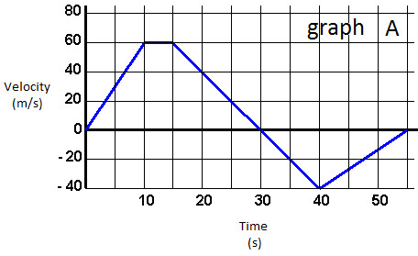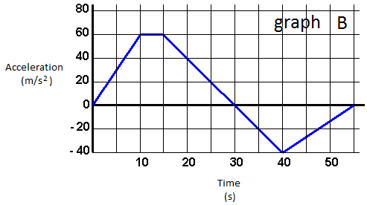
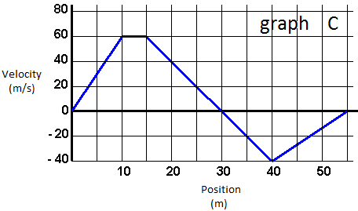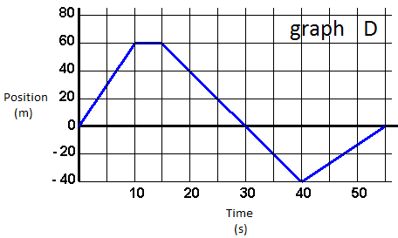
1. Velocity is the slope of what graph?
2. Acceleration is the slope of what graph?
3. The horizontally flat section on graph D represents an object doing what?
4. The horizontally flat section on graph A represents an object doing what?
5. The initial upward section on graph D represents an object doing what?
6. The initial upward section on graph A represents an object doing what?
7. What are the units of the slope of graph A?
8. What are the units of the slope of graph B?
9. What are the units of the slope of graph C?
10. What are the units of the slope of graph D?
11. The downward section on graph A that passes through the x-axis represents an object doing what?
12. The downward section on graph D that passes through the x-axis represents an object doing what?

