Worksheet - Graphing Motion Solutions
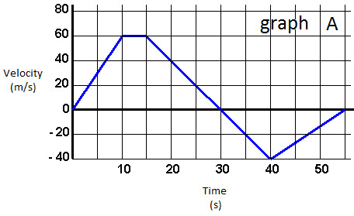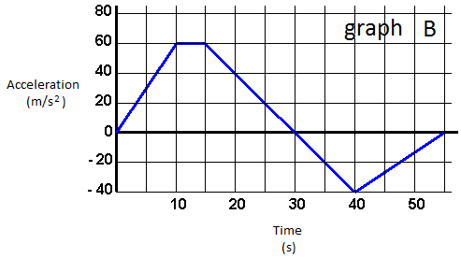
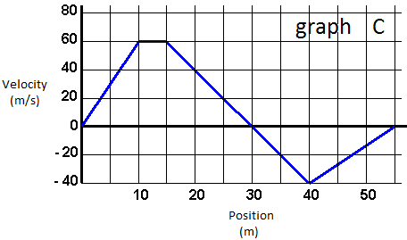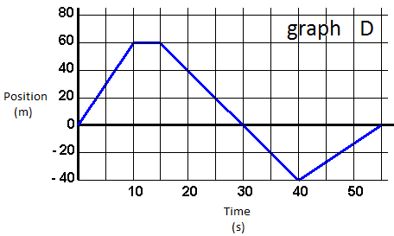
1. Velocity is the slope of what graph?
graph D
2. Acceleration is the slope of what graph?
graph A
3. The horizontally flat section on graph D represents an object doing what?
A stationary object.
4. The horizontally flat section on graph A represents an object doing what?
The object is moving at a constant velocity.
5. The initial upward section on graph D represents an object doing what?
The object is moving farther and farther away from some starting point at a constant velocity.
6. The initial upward section on graph A represents an object doing what?
The object is accelerating, meaning the object is increasing its speed. Its acceleration is constant.
7. What are the units of the slope of graph A?
m/s²
8. What are the units of the slope of graph B?
m/s³
9. What are the units of the slope of graph C?
1/s or s⁻¹ or Hz
10. What are the units of the slope of graph D?
m/s
11. The downward section on graph A that passes through the x-axis represents an object doing what?
The object slows down until a complete halt, and then proceeds to speed up in reverse.
12. The downward section on graph D that passes through the x-axis represents an object doing what?
The object is returning towards the starting position, and then passes it up.

